11/1/2018

Jennifer Brady

Matthew Dobson

Andrew Eissen

Kevin Ramirez

Christian Rondon

Steven Wu

University of Maryland University college

CMSC 495

INSTRUCTOR: DR. ROBINSON

Bookkeeping Project

The Bookkeeping Group

Table of Contents

Software Description 2

Purpose 2

Scope 2

Software Requirement 2

System Specifications 2

Software Management 2

Entity Relationship Diagram 3

Diagram 3

Attribute Table 4

Use Case Scenarios 4

Case 1 (Typical Scenario) 4

Case 2(Expense Changes) 4

Case 3(Some other likely scenario) 4

Functional Requirements 4

Database 4

Client Website 4

Project Organization 5

Project Deliverables 5

Member Structure 5

Project Schedule 5

# Software Description

## Purpose

This document provides an overview of the front and back end development for the Bookkeeping Project. This outline describes the intended functions of the project as well as the organizational plan for project implementation.

## Scope

The end goal of the Bookkeeping project is to provide a web interface for our customer to perform simple bookkeeping for their small business. This tool will allow the customer to……………………..

Our objective is to create a user-friendly experience with future upgrade potential as our client expands their business. By utilizing our project, the customer will more easily be able to track expenditures and expected income. This utility will, hopefully, allow the customer an easier experience in tracking their financial statement and paying their taxes.

# Software Requirement

## System Specifications

* Development Language:
  + Backend
  + Frontend
* Operating Platform:
  + Chrome 70
  + Firefox 62
  + Safari 12
  + Edge 17

## Software Management

Version control will be handled through GitHub. The project repository is located at <https://github.com/BookkeepingProjectGroup/CMSC_495_Bookkeeping_Project>

Communication between the project team will be handled between Slack and Google Hangouts.

## Entity Relationship Diagram

## Diagram

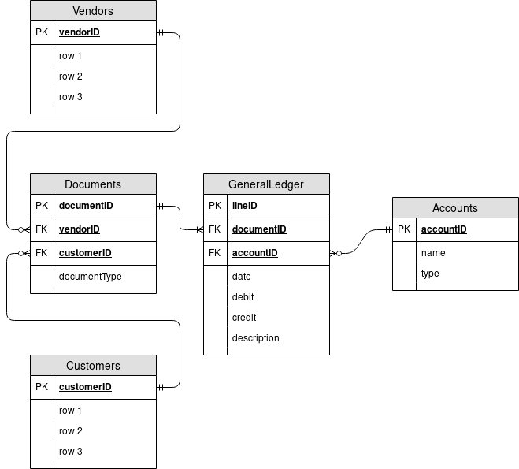

## Attribute Table

|  |  |
| --- | --- |
| Attribute Name | Data Type |
| documentID | Integer |
| vendorID | Integer |
| customerID | Integer |
| documentType | String |
| name | String |
| type | String |
| date |  |
|  |  |
|  |  |
|  |  |
|  |  |
|  |  |
|  |  |
|  |  |
|  |  |
|  |  |
|  |  |
|  |  |

# Use Case Scenarios

## Case 1 (Typical Scenario)

## Case 2(Expense Changes)

## Case 3(Some other likely scenario)

# Functional Requirements

## Database

i.e. inputs, outputs, lookups, modifications, etc

## Client Website

navigation, login, security, data access options, etc

# Project Organization

## Project Deliverables

* Project Plan
* Software Design Information
* Software Test Documentation
* Bookkeeping Database
* Customer Web Interface

## Member Structure

Each member will participate in all aspects of this project. Team members have specific roles assigned roles as follows:

|  |  |  |
| --- | --- | --- |
| Group Member | Primary Role | Secondary Role |
| Jennifer Brady |  |  |
| Matthew Dobson |  |  |
| Andrew Eissen |  |  |
| Kevin Ramirez |  |  |
| Christian Rondon |  |  |
| Steven Wu |  |  |

## Project Schedule

|  |  |  |  |
| --- | --- | --- | --- |
| Task | Duration(days) | Start | End |
| Project Plan | 7 | October 29, 2018 | November 4, 2108 |
| 1. Software Scope | 5 | October 29, 2018 | November 2, 2018 |
| 1. Software Languages | 5 | October 29, 2018 | November 2, 2018 |
| 1. Update ER Diagram & Attribute Table | 1 | November 2, 2018 | November 2, 2018 |
| 1. Assign Roles | 1 | October 30, 2018 | October 30, 2018 |
| 1. Use Case Scenarios | 2 | November 2, 2018 | November 4, 2018 |
| 1. Functional Requirements | 2 | November 2, 2018 | November 4, 2018 |
| User’s Guide and Test Plan | 7 | November 5, 2018 | November 11, 2018 |
| 1. Develop Test Cases | 5 | November 5, 2018 | November 9, 2018 |
| 1. Write Test Plan Document | 1 | November 10, 2018 | November 10, 2018 |
| 1. Review | 1 | November 11, 2018 | November 11, 2018 |
| Project Design | 7 | November 12, 2018 | November 18, 2018 |
| Phase 1 Development | 7 | November 19, 2018 | November 25, 2018 |
| Phase 2 Development | 7 | November 26, 2018 | December 2, 2018 |
| Phase 3 Development | 7 | December 3, 2018 | December 9, 2018 |
| Final Review and Testing | 7 | December 10, 2018 | December 16, 2018 |